**Department of Computer Science**

**Muhammad Fahad (FA19-BSSE-0014)**

**Question 1/Task 1:**

**Answer:**

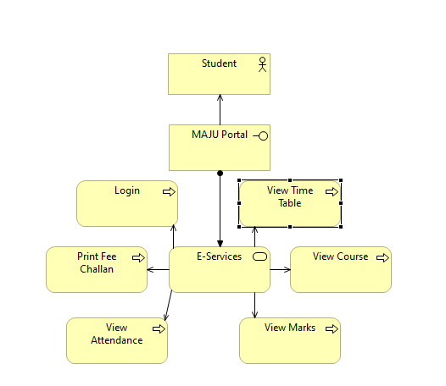

**Question 2/Task 2:**

**Answer:**

